BINDURA UNIVERSITY OF SCIENCE EDUCATION    CENTRE FOR EDUCATIONAL TECHNOLOGIES INNOVATION AND DESIGN | GOOGLE FOR ADMINSTRATIVE STAFF : Boosting Your Productivity And Collaboration Skills  Welcome to a three day workshop meant to equip office administrators with google workspace tools to boost their productivity and collaborative skills.  Google Workspace is a productivity suite of cloud-based applications that includes business versions of apps such as Gmail, Docs, Drive, Calendar, Meet, Sheets, Slides, Forms, Chat, and more. It is designed to help individuals and organizations work more efficiently and collaboratively from anywhere on any device.  Google Workspace is easy to use and offers a range of features and functionalities that can help users boost their productivity and collaboration skills. It allows users to create, edit, and share documents, spreadsheets, presentations, and forms in real-time with others. It also offers features like video conferencing, chat, and mobile apps that make it easy to connect with teammates and work on the go.
MASTERING GOOGLE WORKSPACE
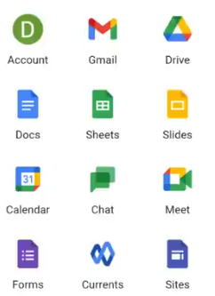
Overview

About the course


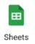


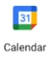



The course is going to look on the following google workplace tools one after and the other and then show how they coordinate for the purposes of productivity and collaboration. The course will progress by self-pace using the book activity, sometimes quizzes and live webinars

