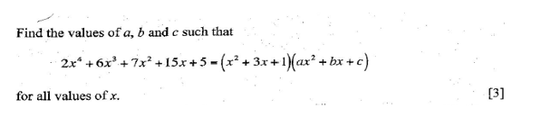**Question One**

Solution

Complete correct method

either division or equating coefficient

obtains a =2, b=0 and c=5 [3]